Developments in Mathematics
(Adapted from Klir)

- Limits of formal systems are recognized (Gödel)
- Trends to Generalize:
- from quantitative (differential equations, etc.) to qualitative (discrete, combinatorical, symbolics, more difficult for humans in some ways, but more adapted to the digital computer)
- from functions to relations
- from graphs to hypergraphs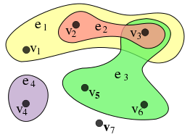
- from probability measure to non-additive (monotone) measures
- from ordinary (though not necessarily Euclidean) geometry to fractal geometry 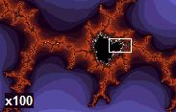
- from ordinary automata to cellular automata
- from precise analysis to interval analysis and fuzzy analysis
- Tolerance for imprecision (fuzzy logic and approximate reasoning)
- Tolerance for local inconsistency (logic of inconsistency)
- Focus on singularities (catastrophe theory)
- Emphasis on multiple-objective criteria optimization
- Emphasis on nonlinearity
- Emergence of category theory
- Emergence of chaotic systems

